

Offshore Renewable Energy Declaration

Hunter, NSW—Public Consultation Summary Report

July 2023

# Table of Contents

Table of Contents 2

Introduction 3

Development of the Notice of Proposal 3

Consultation process 3

Public consultation 3

First Nations consultation 4

Community information sessions 4

Online local industry sessions 4

Other consultation 4

Analysis of submissions 5

Overview of submissions 5

Types of respondents 5

Individuals 5

Organisations 6

Feedback within submissions 7

General sentiment 7

Benefits of offshore renewables and opportunities for the region 7

Addressing climate change, emissions reductions and clean, renewable energy 7

Community and local economy 8

Environment 8

Visual amenity 8

Commercial and recreational fishing 8

Shipping 9

Other opportunities and benefits 9

Existing marine users and local concerns 9

Environment 9

Visual amenity 10

Commercial fishing 11

Recreational fishing 12

Community 13

Other concerns or issues 15

# Introduction

On 23 February 2023, the Minister for Climate Change and Energy announced that an area offshore between Norah Head and Port Stephens, NSW, for this purpose referred to as the Hunter region, was being considered for its suitability to be declared as an offshore renewable energy area under the *Offshore Electricity Infrastructure Act 2021*. This is the second area to be considered under the legislative framework and is another step forward in enabling the development of offshore renewable energy in Australia.

The purpose of this report is to provide an overview of consultation on the Notice of Proposal for the Hunter proposed area, including a summary of the responses received during targeted and public consultation. The responses received as part of the public consultation process reflect considerable time and effort on the part of the respondents. The submissions provided valuable information for the Minister when deciding to declare an area off the Hunter region, NSW as suitable for offshore renewable energy infrastructure.

The opinions expressed in this report were presented by stakeholders during the public consultation period and do not necessarily reflect the views of the Australian or NSW governments.

# Development of the Notice of Proposal

The Notice of Proposal to declare an area off the Hunter region, NSW as suitable for offshore renewable energy infrastructure was developed through consultation with Commonwealth and NSW Government agencies.

# Consultation process



## Public consultation

The Minister published the Notice of Proposal for the area off the Hunter region on 23 February 2023. This commenced the statutory public consultation period as required under the *Offshore Electricity Infrastructure Act 2021*. Members of the public were able to make submissions via the Department of Climate Change, Energy, the Environment and Water’s ‘Have Your Say’ web platform. On 28 April 2023, the public consultation period closed.

The Notice of Proposal was accompanied by a dataset titled ‘*Offshore Electricity Infrastructure Act 2021* – *Proposed Area – Hunter, NSW’* that identified the proposed area to be declared. An indicative map of the proposed area was also included in the notice. The Consultation Hub page included several resources to provide respondents with additional information in relation to the proposal. This included:

* A document providing an overview of the proposed area and FAQs titled ‘Overview of the Proposed Area – Hunter, NSW’.
* A document providing an overview of existing marine users and interests in the vicinity of the proposed area titled ‘Marine Users and Interests – Hunter, NSW’.
* A shapefile of the proposed area for download.
* A link to an interactive map of the proposed area hosted by Geoscience Australia.

Information on the public consultation was shared across a number of platforms, including [on](https://www.dcceew.gov.au/) the department’s [website](https://www.dcceew.gov.au/energy/renewable/establishing-offshore-infrastructure) and social media channels: Twitter, Facebook, Instagram and LinkedIn. The department carried out several forms advertising for the proposal, including posts on social media, notices in local and regional newspapers, articles in local newspapers, radio advertisements and flyer drops to residents in coastal areas adjacent to the proposal.

The announcement itself also received media coverage, and information on the proposed area was shared more broadly across bigger regional newspapers and websites.

The purpose of the public consultation was to inform the community of the proposal and seek feedback on current uses and users of the area to inform the Minister’s decision on whether the proposed area is suitable for offshore renewable energy development.

## First Nations consultation

The department contacted the Awabakal, Bahtabah, Biraban, Darkinjung, Karuah, Mindaribba and Worimi Local Aboriginal Land Councils (LALCs) whose country is adjacent to the proposed area. The LALCs were contacted by phone and email to introduce the proposal, offered an in-person meeting to discuss the proposal and asked to provide any feedback. An in-person meeting on country was held with Biraban LALC in March 2023 to discuss the proposal.

## Community information sessions

The community was invited to participate in community information sessions held during the consultation period across the Central Coast, Lake Macquarie, Newcastle, and Port Stephens. In total, seven community information sessions were held in Wamberal, Doyalson, Swansea, Newcastle, Bar Beach, Nelson Bay and Hawks Nest from 6 March to 9 March 2023, attracting more than 300 attendants.

For each session, departmental staff were on-site and available to talk to members of the community, together with representatives from the Energy Corporation of New South Wales (EnergyCo).

At the sessions, attendees were briefed by department representatives on elements of the proposal, provided with the opportunity to ask questions, discuss key issues, and understand the importance of providing feedback via a submission.

## Online local industry sessions

Relevant local industry stakeholders were invited to participate in online, industry specific sessions held during the consultation period. Six sessions were held between 20 March to 23 March 2023. These sessions were targeted to the following industry groups: Aviation, Commercial Fishing, Recreational Fishing, Tourism, Local Business and Community Groups.

A total of 18 individuals attended these online sessions. These sessions allowed targeted discussions on the interaction of potential offshore renewable energy projects with specific local industries and gave an opportunity to answer any questions local industry representatives might have, to better equip themselves to provide informed feedback to the consultation process.

## Other consultation

The department also met with residents from Norah Head and the Love Norah Head group to hear about their concerns over the proposal and dissatisfaction with the consultation process.

# Analysis of submissions

The department undertook an analysis of the submissions received. The analysis was to understand overall public sentiment of the proposal represented in the submissions, and to identify the range of concerns and benefits of the proposal to assist the Minister’s decision whether to declare the area as suitable for offshore renewable energy.

# Overview of submissions

## Types of respondents

Respondents were able to respond as an individual or on behalf of an organisation. A total of 1916 submissions were received. 107 submissions (6%) were made on behalf of an organisation, 15 respondents did not specify, and the remaining 1,794 submissions (94%) were made by an individual or individuals.

### Individuals

Individuals were asked to identify what best describes themselves and Figure 1 shows the breakdown. Most individuals identified as a local resident (74%).

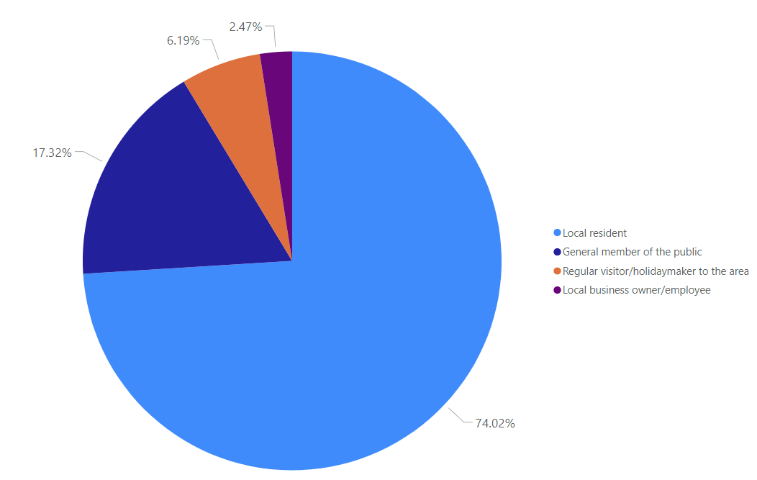

Figure 1 – Responses of individuals

Respondents were also asked to identify their postcode. A breakdown of the locations of the individuals who made submissions can be seen in Figure 2.

Of the submissions from individuals, over 96% of submissions were from residents in NSW. Over 80% of the individual submissions received were from residents in the five coastal local council areas (Central Coast, Lake Macquarie, Mid-Coast, Newcastle and Port Stephens), and 4% were from the broader Hunter council areas (Cessnock, Dungog, Maitland and Singleton). Over 40% of all individual submissions identified the Central Coast as their location.

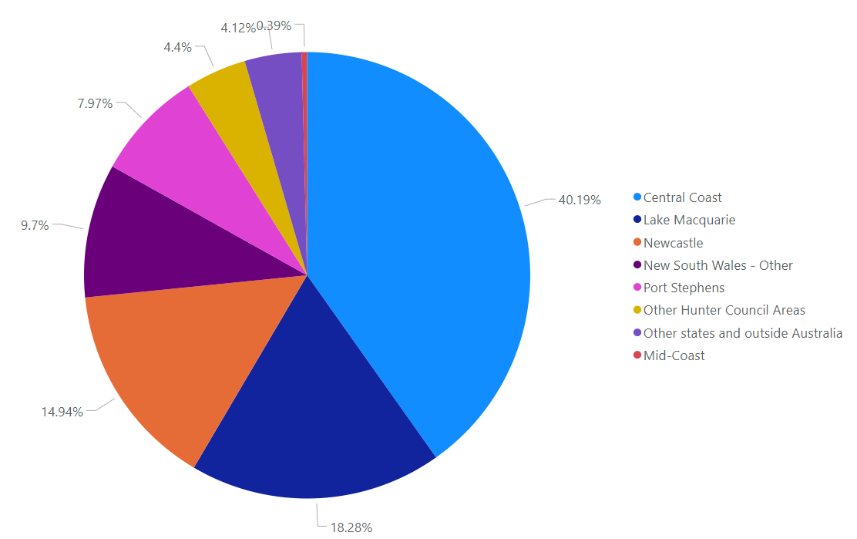

Figure 2 – Locations of individuals submissions

### Organisations

Organisations who made a submission were asked to categorise the sector that best describes their organisation. Figure 3 shows the breakdown of sectors for all responses from organisations. Overall, the largest portion of responses from organisations came from non-government or community organisations (31%). The next most represented sectors were from the energy, electricity and renewables industry (22%) and peak bodies or unions (13%).

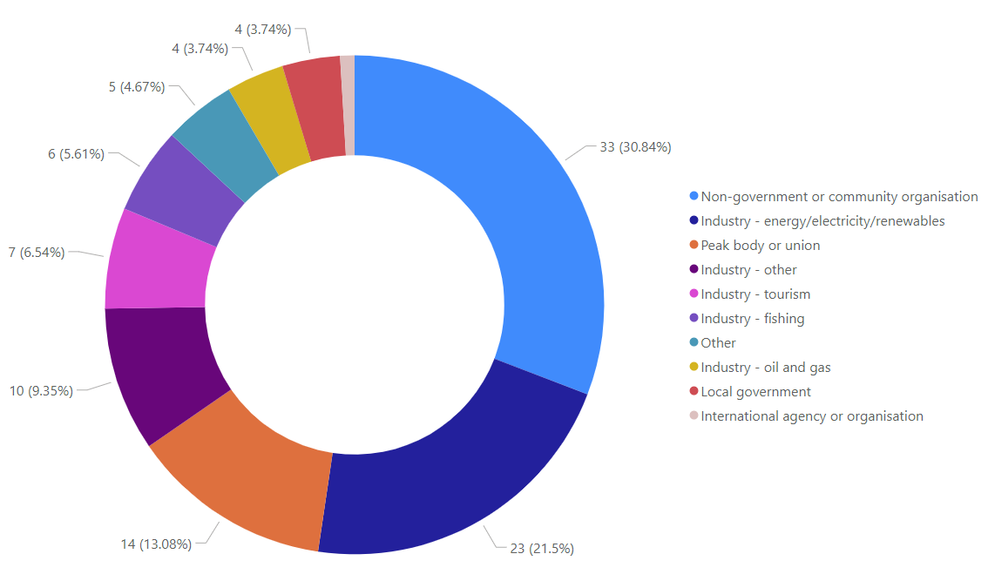

Figure 3 – Submissions from organisations by sector

# Feedback within submissions

## General sentiment

All submissions were asked to select whether they were generally supportive or opposed to the proposal, and if they had any specific concerns. Figure 4 shows the breakdown of the sentiment towards the proposal. 66% of submissions were opposed to the proposal, with 19% of people that were opposed having specific or other concerns. 31% of submissions were supportive of the proposal, with 7% of these noting that they had specific or other concerns.

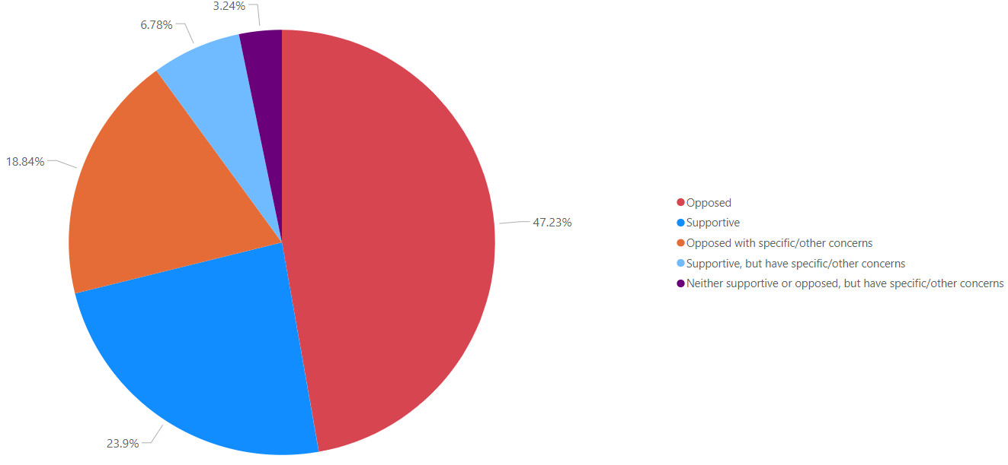

Figure 4 – Sentiment towards the proposal

## Benefits of offshore renewables and opportunities for the region

A number of submissions noted benefits of offshore renewables and opportunities for the region, across various themes. Figure 5 shows the percentage of submissions that identified benefits and/or opportunities across the main themes. These are expanded on in the sections below.

Figure 5 – Submissions identifying benefits or opportunities

### Addressing climate change, emissions reductions and clean, renewable energy

Support for clean energy was raised in 312 submissions and was focused on the positive environmental implications of transitioning away from a fossil-fuel reliant energy system. Submissions in support of clean energy also mentioned the benefits of improving air quality, having a cleaner environment, and reducing the coal industry’s carbon footprint. Many submissions mentioned the time sensitive nature of developing renewable energy capacity, and the declaration of a suitable area for offshore renewable energy in the Hunter region was seen as an opportunity to reduce the risk of Australia’s decarbonisation.

Renewable energy was mentioned as one of the central means of addressing climate change, and some submissions commented that the long-term benefits would outweigh short-term impacts associated with the construction of the offshore renewable energy infrastructure. Additional benefits also noted in submissions included cheaper energy, improvements to energy security through grid diversification, and fewer risks to groundwater and farmland.

### Community and local economy

Approximately 17% of submissions noted benefits of offshore renewable energy projects to the community and local economy. These included broad sentiments focused on economic benefits such as an increase in job opportunities and investment in the region. Other submissions raised the possibility that a new offshore renewable energy industry may assist in transitioning coal workers into new employment. A subset of these submissions noted the potential for an increase in opportunities for local training and apprenticeships.

Submissions also emphasised potential community benefits, such as the opportunity for a new offshore renewable energy industry to work closely with local and Traditional Owner communities to produce broader shared benefits, as well as a potential increase in local tourism and other investment opportunities.

### Environment

About 359 submissions (19%) were supportive of offshore renewable energy but wanted to ensure that the marine environment was protected, with any impacts being avoided, reduced, or compensated for. It was suggested that any ecological studies done by licence holders not be done individually but in a coordinated manner to reduce environmental impact. It was also requested that adequate research be conducted into bird flight paths and the data be used in positioning and operating wind turbines to ensure no impact to bird life. Mitigation strategies such as suspending construction during the whale migration period and setting up exclusion zones for fish were suggested.

A small number of submissions noted the potential environmental benefits of offshore renewables, separate to the broader climate benefits associated with renewable energy. These submissions identified the potential for offshore renewables to create new habitats for marine life in the offshore area by functioning as artificial reefs.

### Visual amenity

Support for offshore wind turbine visibility was expressed in 262 submissions. This represents approximately 14% of all submissions received. These submissions expressed they were not concerned by visual impacts, noting that coal ships and other shipping associated with the Port of Newcastle have been visible offshore for many years, and had not adversely impacted visual amenity.

Submissions in support also expressed that offshore wind turbines would be a positive visual indication of the region’s support for the transition to renewable energy and action on climate change and would be preferential to the visual impact of coal ships, mines and power plants currently in the region. Community climate organisations expressed support for visual amenity of offshore renewable infrastructure as noted above, stating that they considered visual impacts to be minor and less important consideration against the need to transition away from fossil fuels.

### Commercial and recreational fishing

There was more support for the benefits of offshore renewable energy to recreational fishing (137) than there was for commercial fishing (101), this was largely due to submissions noting that the additional habitat created around wind turbines would improve fishing for recreational activities, if smaller boats are still allowed to access areas close to turbines.

Support was centred on the potential for floating wind turbines to provide habitat for fish species and operate as fish aggregation devices. There was support for a reduction of commercial fishing pressure within the area which would lead to an increase of fish stocks.

Other comments of support suggested that offshore renewable energy could provide:

* New opportunities for commercial fishing charters.
* Ecological benefit for benthic species associated with additional hard substrate.
* Unexpected increases in biodiversity.
* Increase recreational fishing tourism in adjacent coastal towns.

### Shipping

A very small number of submissions were supportive of the proposal as presenting an opportunity to determine safe vessel operation in and out of the Port of Newcastle.

### Other opportunities and benefits

Approximately 70 submissions noted other opportunities or benefits relating to offshore renewables. Many of these submissions expressed general positive sentiment towards offshore renewable energy and the need for the industry to be adopted in Australia as soon as possible.

Several potential offshore wind farm developers provided submissions, noting the significant opportunities the declaration of this area opens up for the industry and the region more broadly.

## Existing marine users and local concerns

Many submissions noted concerns and discussed those who are currently using this marine area. Figure 6 shows the percentage of submissions that identified concerns and existing marine users across the main themes. These are expanded on in the sections below.

Figure 6 – Submissions identifying concerns or existing marine users

### Environment

Approximately 1080 submissions identified concerns with the environment. Approximately 800 of these respondents were concerned that the construction, operation, and decommissioning of offshore wind farms would interfere with the marine ecosystem, causing damage to marine life including whales, birds, fish, sharks, dolphins and the seabed. Respondents considered that the risk of damage to the environment and pollution from offshore renewable energy infrastructure was high in comparison to the overall benefits.

Of all the submissions received, 29% were concerned about impacts to whales, 20% were concerned about impacts to birds, 10% were concerned about impacts to fish and sharks and 9% were concerned about the impacts on seabeds and reefs (Figure 7).

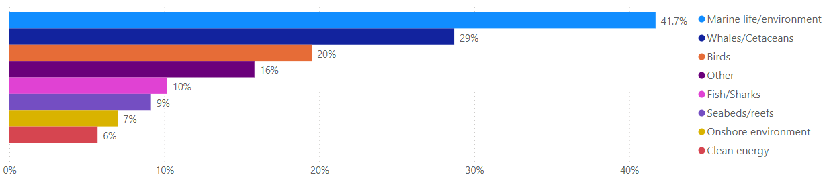

Figure 7 - Submissions with environmental concerns raised

The respondents mentioned that the proposed area overlapped with migratory whale corridors along the entirety of the coast between the Central Coast and Port Stephens, with concerns that whales have only just started to frequent the area again more regularly. There were concerns raised that the noise and vibration during the construction and operational phases of wind farms would interfere with the sonar mechanism that whales use to navigate. Many of the respondents were concerned about bird mortality from the blades of the turbines. Some respondents who raised concerns regarding bird life, made comments on impacts to specific species such as the endangered Gould’s Petrel found near Cabbage Tree Island, and other birds such as shearwaters, sea eagles, hawks, and albatross.

Several submissions raised concerns over the environmental footprint of turbine infrastructure and whether recycling of blades and turbines was a viable process. In 99 submissions, concerns were raised on the theme of clean energy. Among these submissions, statements putting forward views that wind turbines were failed technology, had large pollution risks from loss of oil, and did not offset their own carbon footprint, were common.

Other environmental concerns raised in submissions included oil spills and fire from the wind turbines, sea water causing corrosion on the turbines, and contaminants leaching into the water. Many submissions were concerned about impacts on the seabed, including on reef structures and the damage to the seafloor. Concerns were also raised about impacts on the coastline. These submissions raised concerns regarding coastal processes such as erosion and sand displacement. A subset of submissions concerned with environmental impacts also highlighted concerns regarding a lack of existing environmental studies on the impacts of offshore wind farms on the marine environment.

Several submissions made suggestions on how to mitigate the impact offshore renewables may have on the environment. It was suggested that any ecological studies done by the proponents not be done individually but in a coordinated manner to reduce environmental impact. It was also requested that adequate research be conducted into bird flight paths and the data be used in positioning and operating wind turbines with no impact to bird life. Mitigation strategies such as suspending construction during whale migration period and setting up exclusion zones for fish were suggested.

### Visual amenity

The impact of offshore wind farms projects on the visual amenity of the Hunter region was a prominent concern raised throughout consultation. Of the 1916 submissions received, 948 (49%) mentioned the impact on visual amenity as a concern.

The majority (87%) of submissions with visual amenity concerns were residents within the 5 closest local council areas (Central Coast, Lake Macquarie, Newcastle, Port Stephens and Mid-Coast). 48% of submissions which identified concerns for visual amenity were made by residents in the Central Coast council area (Figure 8).

Submissions outlined concerns with the reduction of visual beauty from places of natural significance, with both individuals and community groups identifying concerns with changes to the visual amenity from headlands and other natural lookouts. Visual impact to coastal suburbs and heritage places was also identified as a concern. This included concerns for impacts on coastal property prices and tourism, as discussed further in section 0.

Concerns were raised on the visual impact of offshore infrastructure during daylight hours, as well as light pollution caused by hazard and navigational warning lights, required on offshore infrastructure for safety reasons, during the night. Submissions raising light pollution at night discussed dark sky views from coastal lookouts and headlands.

Figure 8 - Visual Impacts: Concern by region

Of the submissions which were concerned with visual impacts, 141 proposed a solution to address these impacts, with the most common solution proposed (60) being for the proposed area being located far enough offshore for any infrastructure to not be visible. The remaining solutions recommended the area be pushed offshore various distances between 10 km and 100 km, with 10 km (19), 30 km (21) or 40 km (18) being the most common distances identified. Other submissions did not suggest a change to the distance, but instead recommended changing the boundaries of the area to exclude areas to the north or south, or to instead develop other areas, with the area offshore of Sydney commonly identified as a preferred alternate in such submissions.

Submissions were also received from several regional groups and organisations, including local councils. Submissions were received from Central Coast Council, Lake Macquarie City Council, City of Newcastle, and Port Stephens Council. All noted community concerns about visual impacts of offshore wind developments. Lake Macquarie and Port Stephens Councils requested that the inshore boundary be moved to 25km and 20km from their council areas respectively to address these concerns. Submissions from local community groups focused on concerns for visual impacts from Norah Head, Mount Tomaree and Tomaree National Park.

### Commercial fishing

Commercial fishing concerns were raised in 25% of all submissions received during the public consultation. Notable fishing industry organisations such as the NSW Wild Caught Fishers Coalition, the NSW Seafood Industry Council, the Commercial Fishermen’s Co-operative Ltd, the Professional Fishermen’s Association and the Sydney Fish Market raised detailed concerns as well as recommendations for helping address issues with the development of an offshore renewable energy industry. These organisations were largely opposed to the declaration and specifically requested engagement during the government declaration process.

Some of the more common concerns raised in submissions were that an offshore renewable energy industry would reduce viability of commercial fishing by excluding fishers from highly productive areas and increasing overheads due to longer transits around infrastructure as well as creating additional navigation hazards.

Other concerns raised in association with commercial fishing were:

* Destruction of seafloor and habitat.
* Noise impacts on target species.
* Short-term, long-term, and cumulative economic and social impacts.
* Impacts on fish species, distribution, and abundance.
* Incompatibility with certain gear types: fish trawl, prawn trawl, ocean trap and some line fisheries.
* Reduction in quota value and catches.
* Impacts on supply of seafood to co-ops and markets in NSW and Australia.
* The impact of oil spills and other pollutants.
* The difficulty and cost for commercial operations to take part in and keep up with consultations.
* The lack of a regulatory framework, policy or procedure to govern how coexistence will be established and function.
* Consultation (at this stage and beyond) might not be proportionate to commercial interest.

Some recommendations were provided in submissions to address challenges and concerns. These included:

* Wider assessment of the impact on supply of sustainable seafood on Australia’s food security.
* Offshore declaration areas should only be made in locations that enable both industries to operate without affecting change or loss in Australia’s capacity to harvest seafood resources sustainably.
* The locations and routes of transmission cables should be agreed with major fishing organisations prior to their deployment.
* Ensuring that all windfarm proposals area subject to thorough and independent environmental impact assessment processes in accordance with the EPBC Act.
* Ensuring large channels between projects to allow access for tourism, fishing, and general boating.
* Developing a policy that covers shared use as well as licence buy backs and compensation schemes for displaced and impacted commercial fishers.
* Consultation with the fishing industry and research to ensure impacts from offshore renewables on commercial fishing are adequately addressed should have costs covered by proponents or commonwealth upfront.

### Recreational fishing

Recreational fishing concerns were raised in 25% of the total submissions made. Like commercial fishing, the most common concerns for recreational fishers involved access to preferred areas and navigation risks. Sport fishing was cited as a compromised activity, should widespread recreational access become prohibited. Some submissions linked recreational fishing to tourism, the decline of which could create broader socio-economic impacts in small coastal towns. Preserving the fishing rights and access of traditional owners was also noted as important among submissions.

Some submissions recommended that recreational fishers be consulted more thoroughly before any restriction zones were implemented, whilst other submissions suggested there should be no restrictions imposed at all.

### Community

Concerns relating to the community were raised in 38% of the total submissions made, making it the third most-raised concern following the environment and visual amenity. Figure 9 below demonstrates the different concerns relating to the community which were raised by respondents, with tourism and the local economy/business/jobs being the most commonly raised.

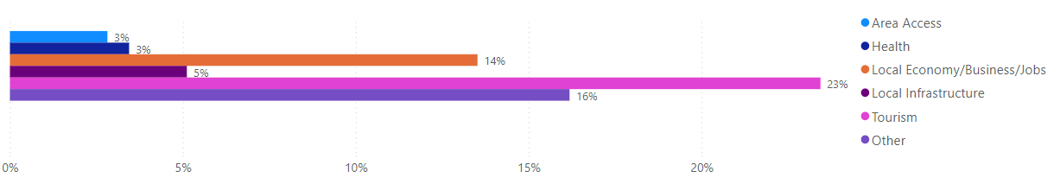

Figure 9 - Submissions with community concerns raised

The following sections outline the specific concerns raised by the public relating to the community.

#### Tourism

There were approximately 449 submissions that had concerns on the impact of offshore windfarms on the tourism industry. Many of the respondents were concerned about the impact to whales and dolphins and the corresponding impact to the tourism sector. Whale and dolphin watching are a significant revenue generator to the tourism industry in the region and many respondents felt that any changes to the area would put operators out of business.

A significant part of the tourism interest in the Newcastle and Port Stephens area is driven by the game fishing industry, which many respondents felt will cease due to detrimental impact on fishes and the marine ecosystem caused by the construction of wind turbines.

Bird watching was another big draw for tourists and many of the respondents felt that offshore wind turbines will impact populations of seabirds and shorebirds. Many respondents also stated that tourism in the area relied on the environment, the pristine beaches and coastal views and were concerned about the negative visual impact of wind turbines calling them an environmental blight upon the seascape. Many people recommended that the wind turbines should be further out to sea.

There were concerns raised specifically around the wind turbines taking away from the beauty of key historic sites like the lighthouse at Norah Head and other culturally sensitive sites. Many respondents wanted to know what the impact might be on holiday activities like surfing, hang gliding, paragliding and parasailing, and if these holiday activities would have to cease. They were concerned that the huge impact to the diverse tourism industry could have repercussions on the real estate industry, cause the closure of many businesses and lead to huge job losses.

It was suggested that developers and local government should work together to address concerns and ensure maximum economic benefit and minimal negative impacts on local communities. Continued consultation with local businesses and industry bodies was encouraged. A community steering committee was suggested to ensure community concerns are addressed.

#### Local economy/business/jobs

Approximately 259 submissions raised concerns regarding the local economy. Most of these submissions expressed concerns regarding the negative impact the introduction of offshore renewables to the area would have on the local economy. These comments particularly emphasised changes to significant existing industries such as fishing and tourism, as being detrimental to the local economy. A portion of the respondents raised concerns regarding the potential for property values to decrease in the regions where offshore wind farms would be most visible.

#### Health

There were 66 submissions that raised concerns with the potential health impacts of offshore wind farms. Many of these submissions raised concerns about public health and safety caused by noise and vibration from the turbines. They were also concerned that the noise from the wind turbines would prevent residents from having an undisturbed sleep at night and the consequences that would have on mental health, stress, and wellbeing of the affected communities. Some respondents were concerned about the impact of electro-magnetic pollution and the increased risk of cancer rates around the world due to wind farms.

#### Onshore impacts and transmission

Infrastructure development onshore was identified as a concern in approximately 150 submissions. Most of the submissions related to concerns with the visual impacts of onshore transmission lines, the lack of capacity of the existing infrastructure and the impacts to the community during construction phases specifically around culturally sensitive sites, access to beach facilities and both the land and marine environment. There were concerns around the lack of information on where the substations or transfer stations would be positioned and how many of them would be set up.

Specifically, respondents were concerned about electromagnetic radiation from high voltage powerlines and the harmful impact this may have on residents and the environment. Many respondents were keen that the government take measures to minimise the impact to the community and the environment – the beach, dunes, Tuggerah lakes, animal life and vegetation during all phases of development.

Many of the respondents have suggested that onshore infrastructure utilise existing transmission networks or are installed near existing high-power usage industries; for example in Newcastle rather than near Norah Head. Other examples were to utilise the existing infrastructure of Munmorah and Vales Point power stations and transmission corridors. There were also suggestions to ensure transmission lines are underground and aren't visible on the immediate coastline. Overhead powerlines were also recommended to connect to existing grid as this would alleviate issues around land ownership.

Some submissions suggested for the government to investigate building, owning, and controlling transmission infrastructure and leasing to developers, to ensure the right outcome for the public.

#### Local infrastructure and other community concerns

The need for engagement throughout the process and guaranteed benefits for local First Nations peoples were also raised as key concerns in the local community. The interests and needs of Traditional Owner groups of the area, and a potential lack of consultation with them, was highlighted as a concern in a subset of these submissions.

Concerns were raised relating to existing local infrastructure, with some submissions highlighting that areas adjacent to the area may not be suitably equipped to handle an influx of workers and new infrastructure needed to support an offshore renewables industry. This was particularly the case for submissions concerning Norah Head on the Central Coast.

#### Shipping

Over 170 submissions raised concerns regarding shipping. These were primarily related to concerns regarding the ability for ships and other vessels to safely navigate through and around wind turbines. A large portion of the submissions concerned about shipping, believe offshore infrastructure would be a major hazard for maritime vessels. The amount of vessel traffic moving in and out of the Port of Newcastle was also a general concern for several respondents. A subset of the submissions raised concerns regarding the introduction of offshore wind farms to the area, and how this would inevitably push shipping routes closer to shore.

One of the most common issues raised in submissions related to shipping was the increased risk of disaster during extreme weather events. These voiced concerns that adding offshore wind turbines to this area would increase the risk of collisions with ships during extreme weather events.

### Other concerns or issues

In addition, 489 submissions raised other concerns or issues which included:

* Advocating for nuclear, coal or fossil fuels or onshore renewables as alternatives to offshore renewables.
* Concerns regarding reliability, viability, and generational capacity of renewable energy, particularly wind power technology.
* Concerns regarding the decommissioning of offshore renewable energy infrastructure and end of life processes, including recycling.
* Concerns with the consultation process, questioning the length of consultation time, amount of information available and level of awareness in local communities of the proposal.
* Concerns relating to whether climate change is a real phenomenon and the severity of the climate emergency.
* A very small number of respondents were concerned about protecting the offshore renewable energy infrastructure from terrorist attacks.
* A small number of submissions claiming the area is too small and restricts the amount of technologically viable space for wind farms to be constructed.